MV Swift voyage for chaplain Maggie as she sails out to support tourism workers
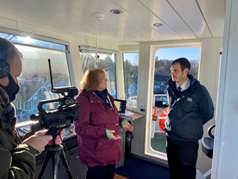
Windermere Lake Cruises has played host to the South Lakes tourism industry chaplain, Deacon Maggie Patchett, as part of work to highlight the support available to workers in the industry.
Deacon Maggie boarded the company’s newest vessel, MV Swift, to record a film to show how the church can help and support to tourism workers whose lives have been badly disrupted by the Pandemic.
Deacon Maggie Patchett filming with MV Swift skipper Rob Beal from Windermere Lake Cruises
“The last two years have been very tough for people in the tourism industry,” says Deacon Maggie Patchett. “The pandemic has led to uncertainty and stress about jobs and money. Peoples’ mental health has suffered and its caused anxiety.
﻿“I just want to let them know we are here to offer a caring, listening ear. Hopefully we can help them cope with those stresses. It’s just about being there for people.”
The Deacon, who is a Methodist minister, says support is available to anyone who works in the industry – those of any faith or non.
On board Windermere Lake Cruises’ 300 seat vessel MV Swift, she recorded an interview for the film outlining her role which will be broadcast at the Diocese of Carlisle’s Cumbria Ministry Development Day in February - an ecumenical event involving clergy and officers from the Church of England, Methodists, United Reform Church and Salvation Army.
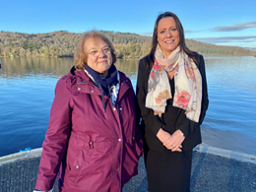
“I just want people to know that someone is here to talk to if they need it. We can arrange to meet outside of work, in a private space, so they can talk freely about their anxieties. It can be really helpful.”
Jennifer Cormack, Sales and Marketing Director for Windermere Lake Cruises, says: “We were delighted to welcome Deacon Maggie on board. The support she offers to people is so important in normal times and especially now after all the disruption to lives caused by the Pandemic.
“She is a regular and welcome visitor to Bowness and Ambleside and speaks to staff regularly. We display her contact details around our premises so that people know they can get in touch if they feel it will be helpful.”
Deacon Maggie meets Jennifer Cormack from Windermere Lake Cruises
Deacon Maggie, who lives in Windermere, has been visiting tourism venues including attractions, hotels, cafés and bed-and-breakfasts in the South Lakeland district since 2017.
“The tourism industry has been through so much disruption in the Pandemic and many people have had worries about their livelihoods,” she says. “If they feel they might benefit from a friendly listening ear they just have to get in touch with me.”
The chaplain has also appealed for volunteers to help carry out the support work. “It’s just about being there for people,” she said. “We are not a counselling service, but if people need a counsellor we can refer them on.”
Anyone who would like to seek support or volunteer to help can contact Deacon Maggie Patchett at tourismchaplain@slakesmethodist.org.uk

